|  |  |
| --- | --- |
| **Full name of student** | Muhammad Afzal Ismail |
| **Student ID number** | 170061238 |
| **Date of meeting (Time/Room)** | 26/02/19 12.00pm  G12 |
| **Date of previous meeting** | 19/02/19 |

**Meeting Agenda:**

|  |
| --- |
| 1. Discuss progress of project: - Reading the csv files  * Log of user actions  1. Discuss use-case diagram 2. Discuss references |

**Action Item/s from the previous meeting**

|  |
| --- |
| 1. Display table according to the titles selected by the user. 2. Update Gantt chart to include unit testing. 3. Research on how to import .txt files by the program.   d. Research and design use-case diagram and state diagrams |

**Matters Arising from the Minutes**

|  |
| --- |
| 1. Discussed which action items have been completed. Action item a. from the previous meeting was only partially completed. At the time of the UI demonstration, the user can import files and display the whole content of the file. Displaying only the columns selected by the user will be completed by next week. 2. Demonstrated how the program reads only the headers on the csv files when imported. The body of the files are read only when the user selects to display the tables. A lot of time was taken to come up with a working solution as each file imported is being placed in its own tab. So, each time the user selects a tab, this tab’s ID must be obtained, and the appropriate content is used. 3. The supervisor also had helpful suggestions to make the UI better for the users. He mentions that the main screen could be larger so as to facilitate viewing of the data being shown. He also mentions where other useful information can be displayed on the main screen. 4. Discussed the use-case diagram (*Appendix A*). Received useful feedback from the lecturer as to where some modifications could be made. 5. Discussed possible references for the project, mainly to compare the data visualiser with other existing software. The ones mentioned by the supervisor are RStudio [1] and tableau [2]. The 2 software will be used as a reference point to compare why this project is different from them. |

**Action Item/s**

|  |
| --- |
| 1. Display table according to the headers selected by the user in the UI. 2. Display statistical information according to the whole dataset and for each particular data column selected by the user. 3. Research on RStudio and tableau. 4. Make automated unit testing, using Junit, for the statistical functions, such as mean, max, min, etc. |

|  |  |  |
| --- | --- | --- |
| **Signature of Student:** |  | **Date: 01/03/19** |
| **Signature of Supervisor:** |  | **Date:** |

**Appendix A**

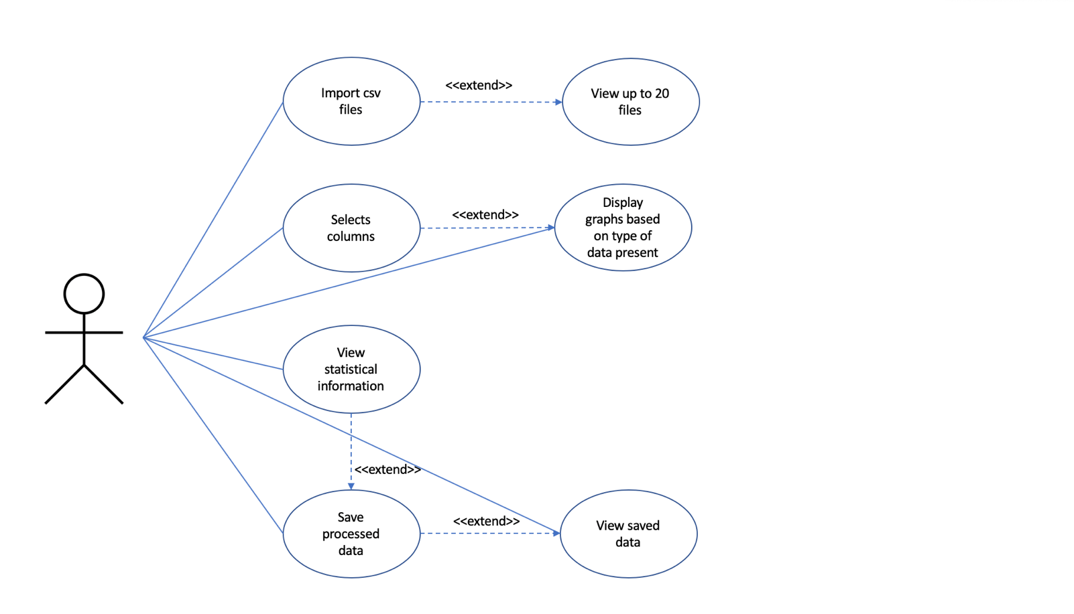

**References**

[1] RStudio, RStudio, 2019 [online]

Available: <https://www.rstudio.com/> [Accessed 1 March 2019]

[2] Tableau, Tableau, 2019 [online]

Available: <https://www.tableau.com/> [Accessed 1 March 2019]